Feeding Liverpool Gathering
Universal Credit Briefing
23rd March 2018

- Introduction
  - Over 80 people attended the latest gathering of Feeding Liverpool, at the LACE centre on 23rd March 2018. The event focused on the roll-out of Universal Credit
  - The purpose of the event was:
- to provide up-to-date information on the roll-out of Universal Credit in Liverpool,
- to hear the opinions of those who will be affected, or from those workers / volunteers who are closest to the ground.
  - The agenda for the day was to hear two expert presentations, followed by questions, and concluding with table conversations based on the concerns and worries of those working on the frontline.

- Pat Dahill, Liverpool South and Knowsley Relationship Manager for the Department for Work and Pensions.
  - Pat’s presentation focussed on the mechanics and practicalities of Universal Credit – how Job Centres would transition people across, how they would support people in this transition, and of particular interest to attendees was the digital journal system that customers would be using to manage their Universal Credit claims and payments. This was the first time that many attendees had seen the ‘live system’. The ‘journal’ page of the system records every interaction that a customer has with their own case, including a time and date stamp.
  - Pat was supported by Ann, Job Centre Manager in Runcorn. Runcorn have already moved across to Full Service, so Ann gave real-life examples of how the transition has worked for people from Job Centre’s perspective.
  - Not all slides shared with the event are available for public circulation. Those that are can be found on the Feeding Liverpool website at http://www.feedingliverpool.org/s/DWP-slides-1.ppt

Notes from the presentations:
  - The primary purpose of UC is to support people into work. This is reflected in the design of the system and also the support mechanisms. A Labour Market Regime will be implemented and depending on each case there will be differing requirements on individuals as part of their work regime.
  - The system is digital dependent. All customers are encouraged to use the online claims and administration process. Experience in Halton shows that most are able to use the system once trained.
  - Job Centre Plus staff have been through their own intensive form of training; internally staff were worried about the online system, but to date this training has worked well and the concerns are largely unfounded.
  - Of key importance is to support people to get an email address and to register on the system using the Government’s online digital service. This will generate a password and a portal for managing UC claims. This can be done early, and all groups of encouraged to ask people to do this.
  - Customers would be supported in the administration and payments by case managers, and by work coaches to help people find and hold down work. Relationships with case managers and work coaches are very important, especially in the early stages to agree commitments and processes; this is the main face-to-face contact and an opportunity to take account of individual circumstances.
  - People migrate onto the system naturally, depending on trigger points – a list of trigger points is included in the slides.
  - A number of the facts / myths around Universal Credit were discussed – payment delays and their reduction, advance payments and rate of pay-back, alternative payment arrangements.
  - Further support is available through Universal Credit online briefings in the presentation

- Richard Machin, on behalf of Child Poverty Action Group
  - Richard’s presentation took a more strategic tone, and outlined the main worries that CPAG has with the roll-out of Universal Credit. Full details are available in the presentations, can be found on the Feeding Liverpool website at http://www.feedingliverpool.org/s/Feeding-Liverpool-Universal-Credit-Briefing.pptx

Notes from the presentation
  - Will the new system result in one of the stated objectives of simplification? There are a number of issues with the roll-out and the final process that means that it will still be complicated for people.
  - The UC system creates the possibility of creating winners and losers. For those closest to the labour market, the system could work positively, and allow alignment with a new flexible labour market and ultimately pay more. For those on the edges of this process though the system will make people worse off and make it more difficult to access work. A key element in this appears to be flexibility in the work commitment.
  - Concerns that the overall level of benefits, subject to austerity, is not keeping pace with the real costs that people are incurring and that ultimately result in an increase in poverty.

- Question and Answer Session
  - The two guest speakers were joined by Debbie Sharpe of Liverpool City Council’s Revenues and Benefits Service.
  - Key concerns and questions raised from the floor during the questions and answer session:
  - Digital delivery – real concern that those without digital access and low skills would be disadvantaged. DWP outlined the provision in place to support people. A number of questions focussed on whether it was possible to circumvent the digital process without a direct response – the clear message was that almost all people will be required to use the digital service. Record in Halton shows that people can manage this.
  - Opt-out – a question was raised about how we would know if people were just opted out of the system. There is much importance put on the registration phase, with people being encouraged to register early to get help and support, and once on the digital system, people should not ‘get lost’. Question reflected concerns from the floor that homeless people may struggle with requirements.
  - Support structures – question raised as to whether there was enough support to manage the transition. DWP outlined measures taken including the delegated scheme to local authorities called Universal Support, digital provision in Job Centres, and the work of claims managers and job coaches. Liverpool City Council have been working to coordinate the response locally including provision of hardship funds, LCSS and the work on a Universal Credit Advice Model to ensure good and accurate information.

- Table discussions
  - A full list of recorded table discussions can be found on the feeding Liverpool website at http://www.feedingliverpool.org/s/Flipchart-write-ups-March-2018.docx
  - . The key points based on ‘the key thing you agreed as a table are:
  - More support from DWP to develop links with agencies so that the correct information is given on how / where to refer. Sharing information is the key and also networking providers together.
  - Accessibility – worries about the access for people with any form complex needs. Need to ensure equal access to those with health, disability and language barriers.
  - Concerns over data protection and people knowing what they have given permission for. Does written permission to access client information in one area covers all areas? Concerns also over debt recovery.
  - Digital access – clear concerns over the complexity of the system, the difficulties that this may cause for some clients, and the hidden / increased costs to clients of maintaining digital contact.
  - More training required both for people to be able to access work, but also for community centres to advice on Universal Credit System.
  - Pressure both on DWP staff and also the local voluntary sector – is there additional capacity to manage? How does the Universal Support system work locally?
  - Uncertainties on what is and what isn’t possible, people not knowing what their rights are. Particular pressure on the most vulnerable in this regard. Lack of understanding of what support is available.
  - Government policy is creating a hostile environment. Worried about the majority of cuts to come.

- Summary
  - Kevin Peacock, Feeding Liverpool Steering Group member concluded event, thanking participants for sharing their views so openly, and summarised the discussions using the useful visual description given by Bishop John during table discussions.
  - ”If one imagines that the people for whom Universal Credit works sitting on an A5 piece of paper at the centre of the policy. Surrounding them, on an A4 piece of paper, are people for whom life is more complicated, and they are the ones who will struggle”
  - An attempt at summarising this is found in the diagram below, based on the table comments.

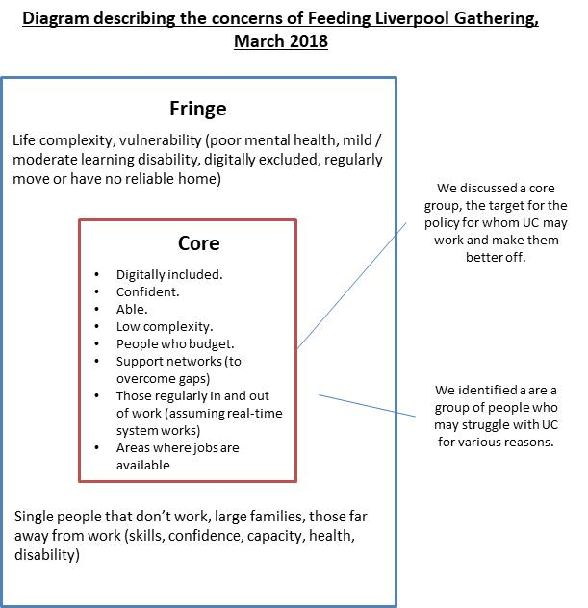

  - Our task is to feed these messages back to policy makers, and to collectively take action to get good information to local people on the changes that are happening.

  - Feeding Liverpool’s focus will remain on those who fall into those marginalised groups, hearing directly from the voices

